**EUROPEAN CULTURE AND HISTORY OUTLINES**

**Coordinator:** Mariangela Severi

**Duration:** 2018-2020

**Topic:** promotion of knowledge of European history and citizenship skills

**Partner countries:** Greece (Athens) -leader-, Italy (Todi), Spain (Almagro), Portugal, Caldas da Rainha, Cyprus (Pafos)

**Total mobility:** during the years of the project, mobility was carried out for 13 teachers and 24 students, involved in the meetings in Portugal, Greece, Spain, and Cyprus.

**Project summary:** Europeans define themselves as such not only on the basis of geographical boundaries but also and above all for their common historical roots. History is therefore a thread that holds Europe together and characterizes its identity. However, it happens that people are not aware of the common origins and the historical context that define European identity; even the students often do not appreciate the meaning of “History” as a discipline, especially for the ways in which it is generally taught and this can represent an obstacle for the development of a conscious European citizenship. The European Culture and History Outlines project therefore aims to act on these aspects, in order to implement awareness of common European values, using history as its main tool. Students of the institutes involved in the project are guided towards experimenting with new teaching / learning methodologies, through the organization and presentation of the results of their research and insights.

At the same time, the students converge the works and activities carried out during the curricular and extra-curricular experiences in a historical synthesis that can promote coherence between nations and increase awareness of the values ​​and policies that characterize the European Union today. To achieve this, students met and worked together during international meetings and constantly interacted through information technology. Visiting significant historical sites during the meetings allowed students to discover or rediscover their cultural heritage and to perceive history as something concrete and tangible. The objectives of the project were also achieved using the **Debate** methodology which favored the development of critical thinking, simultaneously acting positively on the development of language skills and soft skills.

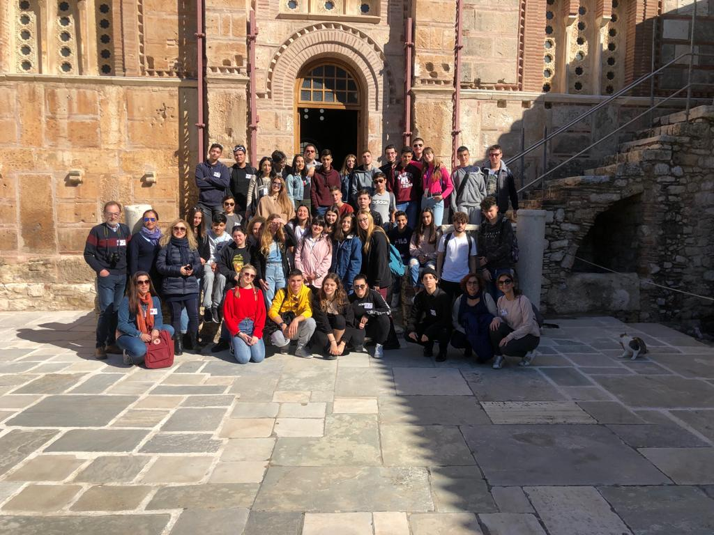

Figure 1 - Meeting in Greece, 2019

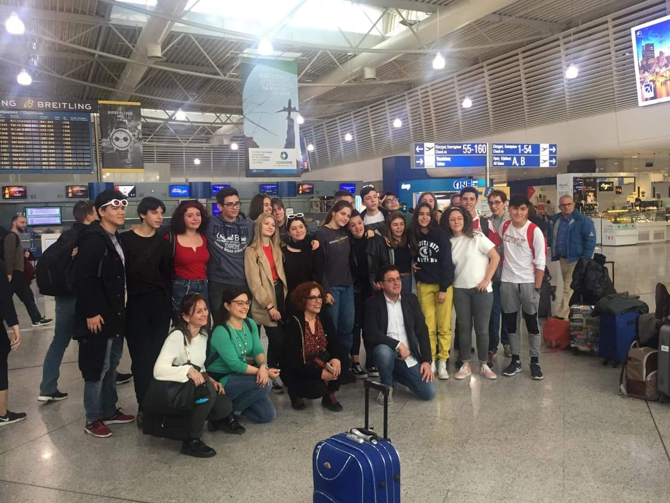

Figure 2 - Meeting in Greece, 2019

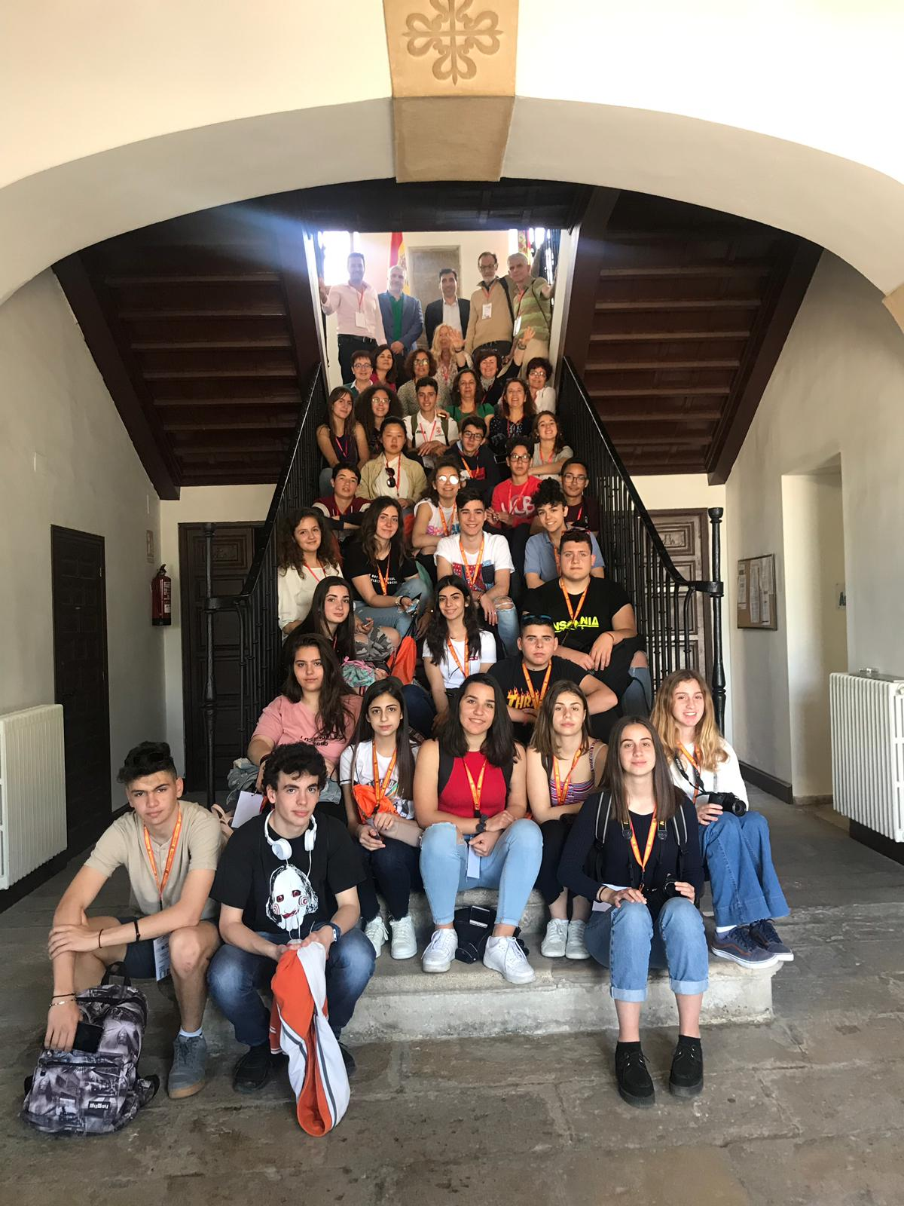 Figure 3 - Meeting in Greece, 2019

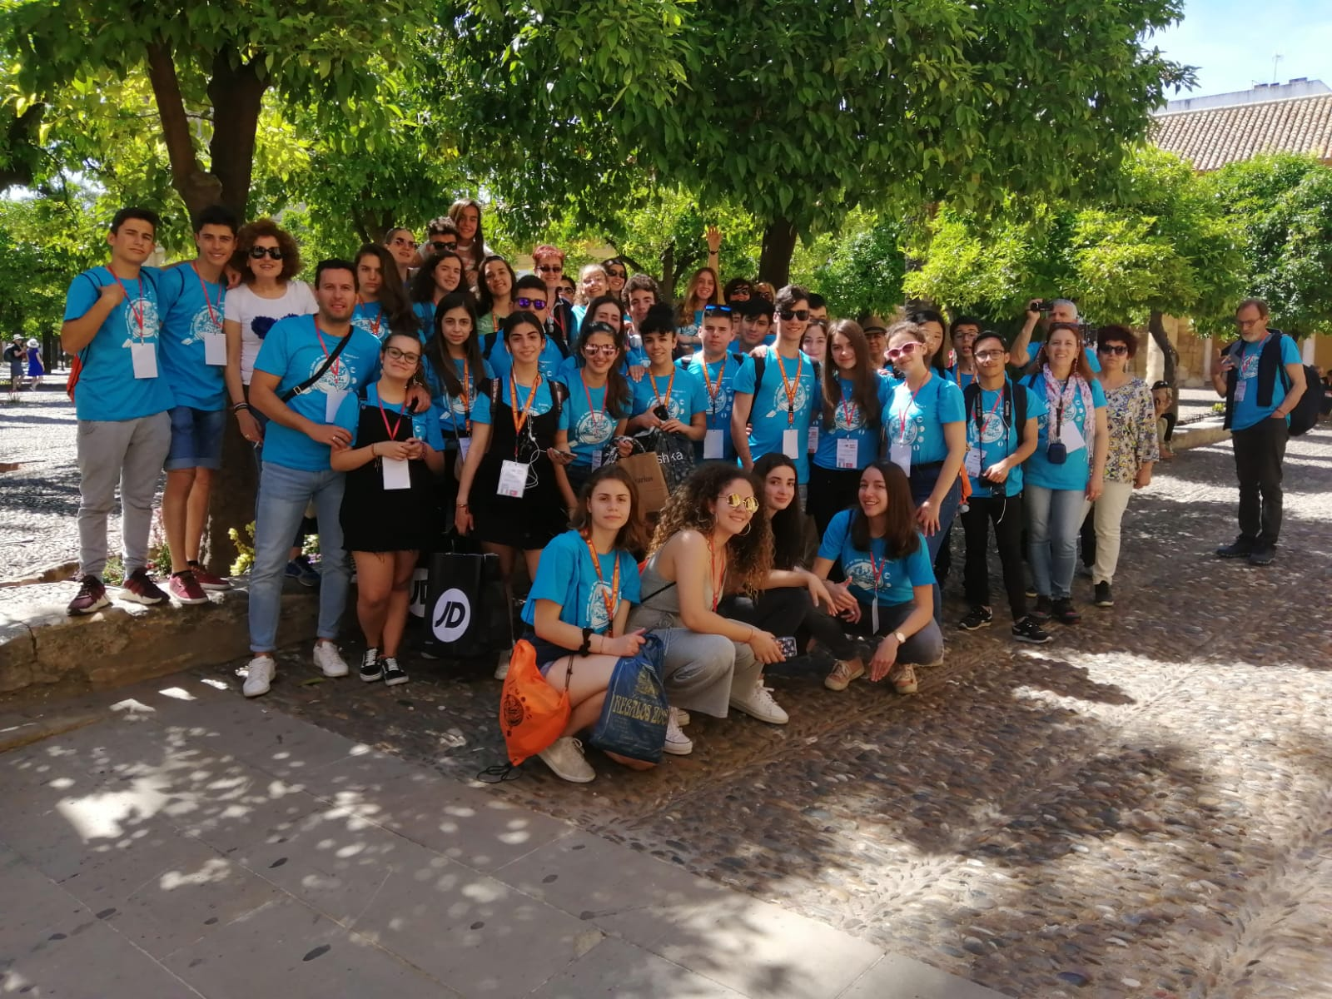

Figure 4 - Meeting in Spain, 2019