**LINKING BUSINESS, ENTERPRISE AND ENTREPRENEURIAL SKILLS INTERNATIONALLY**

**Coordinator:** Concetta Veca

**Duration:** 2015-2018

**Topic:** development of entrepreneurial skills

**Partner countries:** United Kingdom (Hartlepool) -leader-, Italy (Todi), Germany (Waldbröl), Sweden (Norrköping), Turkey (Elazig)

**Total mobility:** 15 students and 13 teachers, involved in the meetings in: Germany, England and Sweden

**Project summary:** The Linking business, enterprise and entrepreneurial skills internationally project is closely linked to the four strategic objectives of ET2020 and in particular to objective no. 4 "Enhancing creativity and innovation, including entrepreneurship, at all levels of education and training", which reminds schools across Europe, in an increasingly complex, competitive and globalized world, of the need to strengthening ties with the world of work, developing creativity and innovation and supporting the development of entrepreneurial skills. This awareness has therefore led us to join the Linking business project with enthusiasm, with the aim both of sharing the good practices already in place in schools and partner countries and of experimenting with new methodologies and new practices, with the aim of building a training offer increasingly adequate to guarantee quality education, in compliance with the demands of the world of work and, at the same time, with the aspects linked to inclusion. The logic of the project was, in fact, precisely that of intensifying the opportunities for all students of the institutions involved, including those with special educational needs, to have an education attentive to the development of citizenship skills as well as entrepreneurial skills The results of the project were to compare the different visions of the countries involved in relation to the word "enterprise", to arrive at a common definition that also specified the skills and competences required of a young person to consciously enter the world of work, in view of a formation that is not only permanent (lifelong), but also “widespread” (lifewide).

Each entrepreneurial competence was then declined into skill levels, creating a framework that could also be used for evaluation.

A European Enterprise Handbook and an Assessment Tool have also been developed, which can be used by teachers both to appreciate the development of entrepreneurial skills and to set new goals for improvement and strengthening.

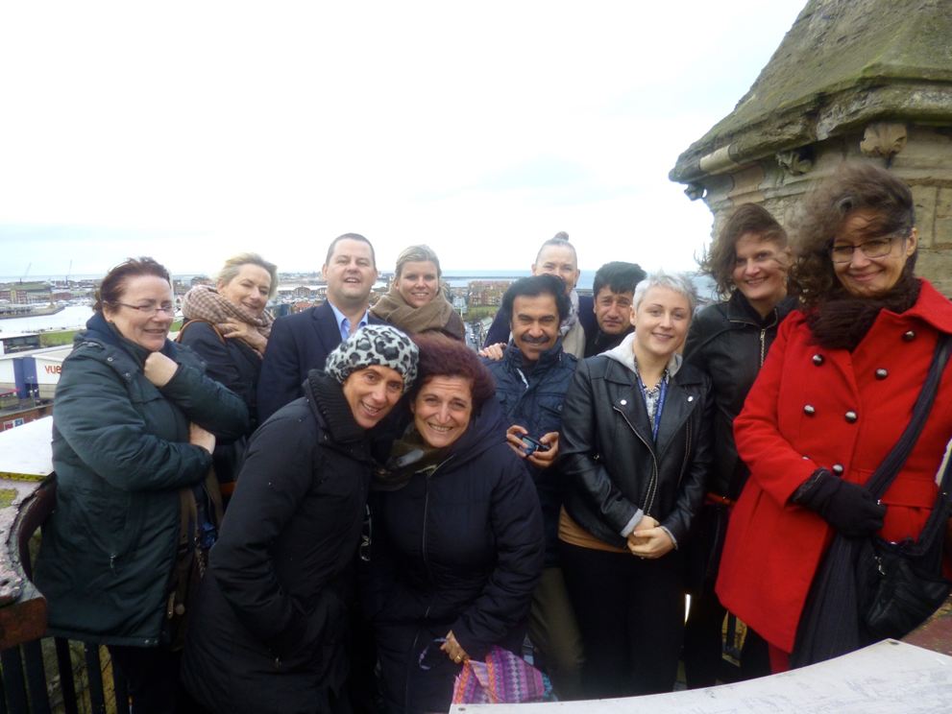

Figure 1 - Meeting in the UK, 2015

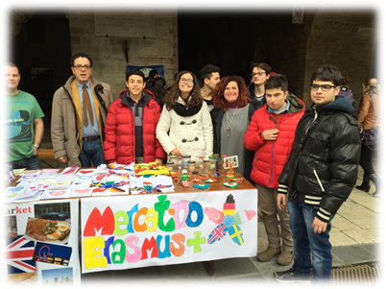

Figure 2 - Meeting in Italy, 2016

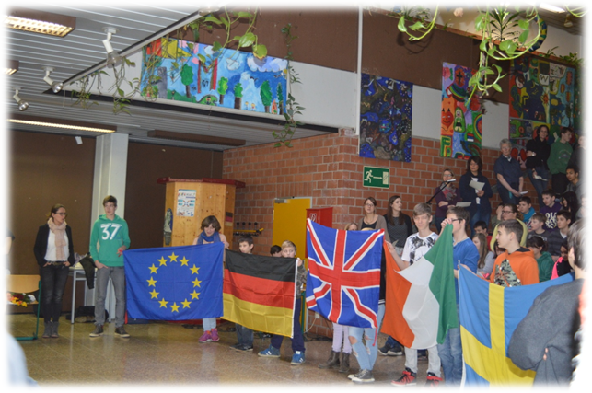

Figure 3 - Meeting in Germany, 2017

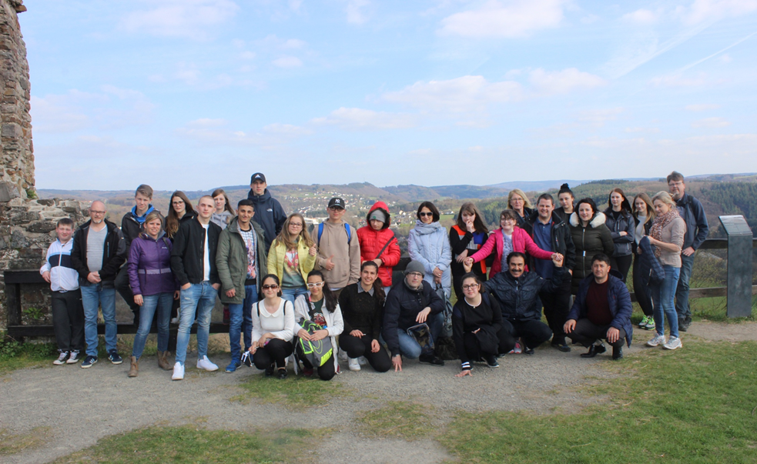

Figure 4 - Meeting in Germany, 2017

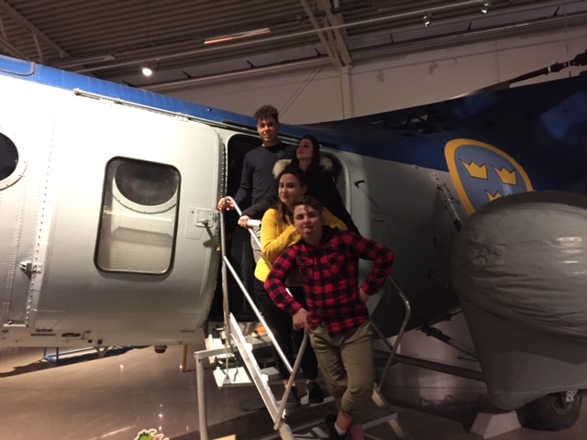

*Figure 5 Meeting in Sweden, 2018*

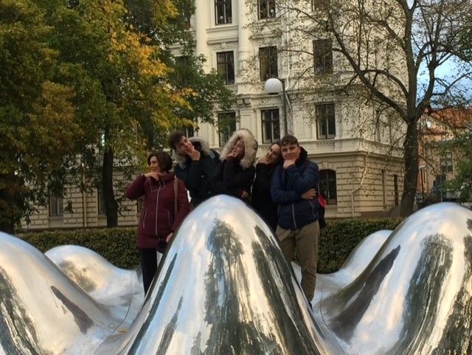

*Figure 6 Meeting in Sweden, 2018*